Multimodal Student Engagement Prediction Using Topic-Aware Comment Filtering and LLM-Based Emotion Sequencing

BVS Hemanth Reddy
Dept of Computer Science and Engg
Amrita School of Computing
Amrita Vishwa Vidyapeetham Chennai, India
Bvshemanth@gmail.com

CH. Nayanesh Reddy
Dept of Computer Science and Engg
Amrita School of Computing
Amrita Vishwa Vidyapeetham Chennai, India
nayaneshchennareddy4@gmail.com
Cheennepalli Mohith Reddy
Dept of Computer Science and Engg
Amrita School of Computing
Amrita Vishwa Vidyapeetham Chennai, India
cheennepallimohithreddy@gmail.com

PMd Kalesha
Dept of Computer Science and Engg
Amrita School of Computing
Amrita Vishwa Vidyapeetham Chennai, India
mdkalesha2007@gmail.com

Abstract

The rapid growth of educational content on YouTube, especially for topics like Python programming,has resulted in the inability to locate the top and quality videos, because the conventional methods of ranking are primarily based on such metrics as views and likes without considering the semantic representation or perception by the audience. The current solutions prioritize ranking based on popularity, simple metrics of engagement, and do not include semantic similarity, sentiment analysis, or intrinsic content quality and lack effective utilization of user comments or an explanation of how decisions are made. To overcome these limitations, this project would introduce a Hybrid Intelligent Ranking System, which is a combination of semantic relevance by embedding the sentences into the system, the sentiment-related emotional appeal by user comments, and the intrinsic quality measures such as depth, lexical diversity and recency, with a hybrid scoring system which is a dynamically changing combination of the engagement and quality to give final rankings and a generative AI model to present analytical descriptions of the findings.

Keywords: Semantic similarity, sentiment analysis, emotional engagement, intrinsic quality score, hybrid ranking, sentiment transformer, YouTube Data API, video ranking.

Introduction

As the use of educational videos on YouTube continues to rise, especially in programming languages like Python, the user is subject to a great number of educational content. Nevertheless, it is not an easy task to choose the most topical and useful videos since such indicators as views and likes are often used, and they are not the indicators of relevance or usefulness of the content, but its popularity. These measures fail to reflect whether a video is suitable to the intention of a learner or whether the viewers attached meaning to the information. Therefore, users are forced to use trial-and-error based mechanisms to find appropriate learning resources, which leads to the development of smarter ranking mechanisms.
The Natural Language Processing (NLP) and retrieval-based systems have advanced and, therefore, semantic representations and the similarity-based methods have become more effective in analyzing textual data. Retrieval-Augmented Generation (RAG) frameworks [4] can be used to augment the retrieval with generation to enhance contextual knowledge, and dense generative frameworks like Dense Passage Retrieval (DPR) [5] can be used to match query and text semantically. BART and other models based on transformers are even more effective in understanding and representing texts [11]. Moreover, complex and large-scale text information can be handled with adaptive retrieval mechanisms and memory augmented models [7], [12].
The literature of document processing and long-context understanding emphasizes that it is necessary to participate in appropriate text processing strategies, which include chunking and contextual segmentation. Chunk-based document comprehension [8] and hierarchical chunking techniques [9] enhance performance in retrieval by maintaining the semantic structure and context-based chunking techniques optimize long-document processing [14]. These results highlight that successful text data processing is a key to other downstream tasks like text ranking and retrieval.
Whilst all this has been achieved, the current video ranking methods are still incomplete because they mostly rely on popularity scores and lack other underlying indicators like semantic similarity, sentiment analysis, or quality of content. They also do not efficiently use user generated comments as a tool of understanding the perceptions of the audience. Moreover, such systems lack transparency and understanding to the reasoning why some of the videos are more ranked than others and the ranking exercise itself is less interpretable [12].
In order to overcome those shortcomings, the given project creates a Hybrid Intelligent Ranking System of YouTube videos that incorporates several analytical elements into a single unit. The system retrieves metadata of video and comments left by users with the help of the YouTube Data API, pre-processes text data, and calculates semantic relevance based on sentence embeddings. Sentiment analysis is used to analyze the comments of users and extract emotional engagement, whereas intrinsic quality is determined by the duration of the comment, lexical diversity, and recency. A weighted hybrid mechanism of scoring is used to combine these components in order to come up with final rankings. Also, a generative AI model to create brief analytical texts on the most popular videos is utilized to enhance the interpretability and system performance [4], [12].

2. PRISMA

PRISMA-Based Literature Selection Process:

To present a clear and well-organized selection of research studies that are relevant to this project, systematic literature review was performed based on the PRISMA (Preferred Reporting Items to systematic reviews and meta-analyses) approach. This process was aimed at identifying semantically similar and sentiment analysis, retrieval-based, and content ranking methods works. During the identification step, 95 records were retrieved in the key academic databases, such as Google Scholar (n = 42), IEEE Xplore (n = 18), ScienceDirect (n = 21), and ACM Digital Library (n = 14). A set of sources was chosen to cover the research that is connected to Natural Language Processing, retrieval systems, and ranking methods. The 37 records were filtered before screening whereby there were 26 duplicate records, 6 irrelevant records were identified by automated filter process, and non-English or non-academic records were filtered (n = 5). Following such a step, there were 58 records that were left to be evaluated. The initial 58 records were considered during the screening stage of filling the records basing on their titles and abstracts to determine their relevancy to the project.

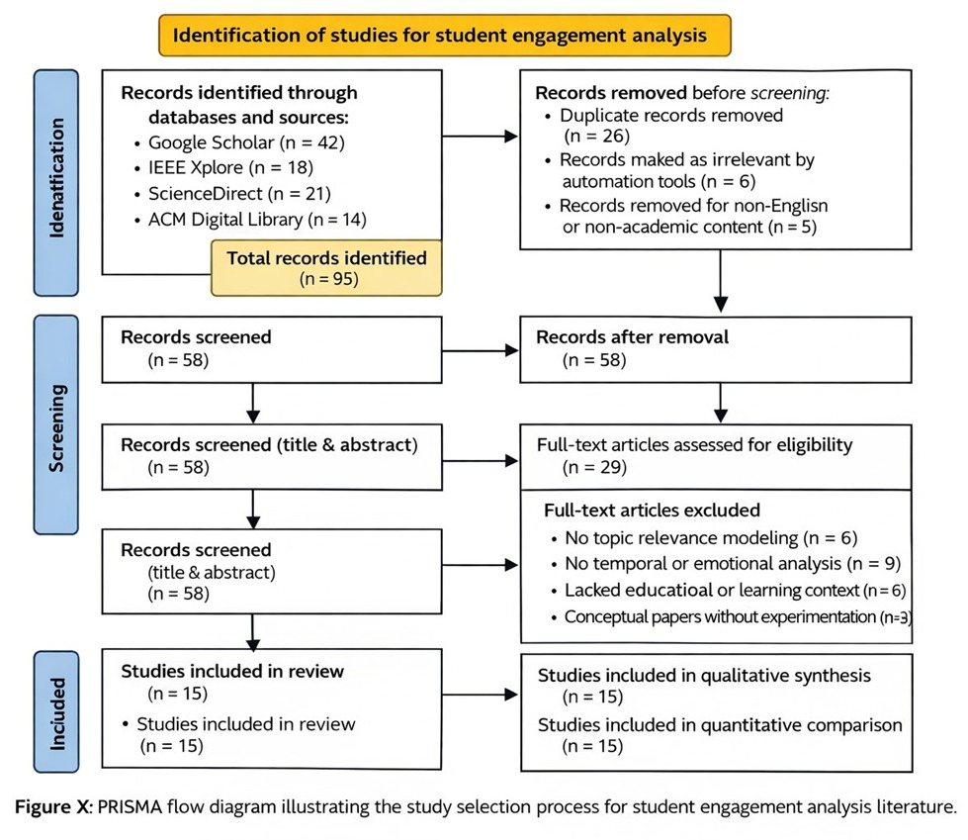

Fig 1:PRISMA

This resulted in 29 full-text articles that were chosen to be evaluated in detail. The predefined criteria were used to exclude the studies which were not in the focus of study, such as not relevance to semantic modeling (n = 6), not emotional or sentiment analysis (n = 9), not educational or contextual (n = 6) and not conceptual studies with experimental validation (n = 3). During the eligibility and inclusion step, another final set of 15 studies was chosen to analyze in detail. These studies were also incorporated in qualitative synthesis as well as quantitative comparison since they directly led to the comprehension of semantic similarity, sentiment analysis, and ranking mechanisms in respect to this project. The PRISMA process helped to be sure that only the relevant and high-quality studies were taken into account, which offered an effective background to find out the gaps in the research and design the proposed hybrid ranking system.

3.Problem Statement

The conventional YouTube ranking strategies do not rely heavily on the surface-level engagement metrics, nor do they incorporate the semantic similarity, sentiment based viewer feedback, or formal intrinsic quality evaluation. Consequently, prioritization of decisions is not a complete measure of relevance to user intent as well as the educational value of the content. As such, a hybrid intelligent ranking system that calculates semantic similarity between a query made by the user and video content, derives and analyzes user comments to assess emotional involvement, calculates intrinsic quality traits (duration, lexical diversity, and recency), integrates analytically signals dynamically using mathematical scoring, and provides analytical explanations to enhance the ranking transparency is required.

4.Problem Identification

As more and more educational material is made freely available on YouTube, especially programming subject matter like Python, the search results provide the user with a large number of videos related to that query. Nevertheless, the current ranking systems are more based on popularity-based metrics like views and likes, which fail to reflect the semantic alignment of the content with the intent of the user, comment-based indicators of the reaction of the audience, or the quality of the content itself. There is no system to judge a video being effective or not in accordance with the learning goal of the query, and no systematic use of user comments to assess the level of emotional involvement. Also, such intrinsic aspects of ranking as the depth of content, lexical richness and recency are not systematically factored into ranking. Moreover, the existing results of ranking are not explainable, which means it is not clear why some videos are rated more than others. The restrictions encouraged the creation of systematic hybrid ranking system.

5. Literature Survey

The latest development in retrieval-based systems has enhanced the capacity to correlate user queries with pertinent material relying on semantic descriptions. As shown by Retrieval-Augmented Generation (RAG) by Lewis et al. [4], retrieval can be used to boost contextual knowledge by adding exterior knowledge. Likewise, Dense Passage Retrieval (DPR) [5] can attempt semantic matching by encoding queries and documents to vectors in an efficient way. Further, Izacard and Grave [6] demonstrated that retrieval comes with generative models, which increase relevance in text-based tasks. Such methods demonstrate the relevance of semantic similarity in the determination of relevant content.

It is also possible to enhance information access through embedding-based retrieval strategies like REALM [10] which combines retrieval with pretraining so that they can utilize knowledge better. Hybrid retrieval methods based on sparse and dense representations also achieve better retrieval performance with an increase in precision and recall as proved by Luan et al. [13]. It is based on these methods that semantic similarity computation is calculated in this project to compare video content and user query.

Models that use transformers have greatly enhanced the understanding and representation of text. Strong contextual embeddings such as the BART model [11] can be used to find semantic similarities and analyze text. Language models that are memory enhanced promote reasoning on textual information as well as on long textual information [7]. Such developments justify the application of embedding models and sentiment analysis methods used in this project.

Textual information requires efficient processing in order to enhance other downstream processes like retrieval and ranking. Chunk-based methods [8] and hierarchical segmentation methods [9] are useful in maintaining structure and enhancing processing of long text. Context-sensitive approaches also add to the knowledge through semantic coherence [14]. These methods focus on the role of textual (video description and comment) information that should be properly managed.

In spite of these developments, the current systems are more focused on retrieval and question answering applications as opposed to ranking applications. The majority of methods consider the semantic matching and do not include sentiment analysis and inherent content quality. Also, the user generated comments have not been effectively used as a ranking signal. Such systems also do not have a single mechanism to integrate various factors like relevance, engagement and content quality.

Based on the review of existing literature, it is clear that there is no single framework that integrates semantic similarity, sentiment-based emotional engagement, and intrinsic content quality to use such a combination in terms of ranking. The current practices also address these aspects separately and do not combine them into a unified score system. This gap is fulfilled in the present project as it suggests a hybrid ranking system which will incorporate semantic relevance, sentiment analysis and content-based features in order to generate more significant and understandable rankings of YouTube videos.

Literature Review:
Table 1: Literature Review

Authors (Year) | Methodology | Advantages | Disadvantages | Research Gap Identified
[1] Buffa et al. (2025) | JusBuild: RAG system for judicial drafting using legal corpora retrieval + LLM | Improves legal drafting accuracy; domain-specific | Limited generalization outside judiciary; depends on corpus quality | Needs multilingual & cross-jurisdiction support
[2] Hindi et al. (2024) | Survey of RAG architectures for legal technology | Identifies strengths and weaknesses of legal RAG | No concrete adaptive solution proposed | Need for dynamic, document-aware chunking
[3] Mukund & Easwarakumar (2024) | Dynamic RAG for legal summarization with adaptive retrieval | Reduces hallucination; improves factual grounding | Uses fixed-size chunking | Chunking strategy not adaptive to document structure
[4] Lewis et al. (2020) | Original RAG combining retrieval + seq2seq generation | Strong performance in knowledge tasks; modular | Retrieval errors propagate; latency issues | Better retrieval alignment & efficiency
[5] Karpukhin et al. (2020) | Dense Passage Retrieval (DPR) using dual encoders | High retrieval accuracy; scalable | Requires large training data; embedding drift | Hybrid dense-sparse retrieval improvements
[6] Izacard & Grave (2021) | Fusion-in-Decoder (FiD) with retrieved passages | Handles multiple documents well; improves QA | High memory usage; slow inference | Efficient multi-document reasoning
[7] Gupta et al. (2023) | Memory-augmented LLMs for legal reasoning | Better long-context reasoning; persistent memory | Memory management complexity; hallucination risk | Reliable memory updating & verification
[8] Wang et al. (2022) | Chunk-based document processing for long QA | Handles long documents effectively | Static chunking approach | No ranking application
[9] Chen et al. (2023) | Hierarchical chunking | Preserves document structure | Complex implementation | Not used for ranking
[10] Guu et al. (2020) | REALM (retrieval pretraining) | Efficient knowledge retrieval | Depends on pretraining | No sentiment integration
[11] Lewis et al. (2020) | BART transformer model | Strong text representation | General-purpose model | Not applied to ranking
[12] Gao et al. (2023) | Adaptive RAG | Improves retrieval dynamically | Focus on generation tasks | No hybrid ranking mechanism
[13] Luan et al. (2021) | Sparse + Dense retrieval | Improves retrieval accuracy | Complex system design | No sentiment or quality integration
[14] Liu et al. (2024) | Context-aware chunking | Better long-text understanding | Static segmentation logic | Not used for ranking
[15] Chen et al. (2024) | Agentic RAG | Improves reasoning and retrieval | High computational cost | No ranking framework

Overall Research Gap :

The reviewed literature [1]–[15] describes that crucial progress has been made in retrieval-augmented generation, dense retrieval, and transformer-based text understanding models in knowledge-intensive NLP tasks. These investigations show the efficiency of embedding-based semantic matching, adaptive retrieval strategies and long context processing methods like chunking, and hierarchical segmentation. Nevertheless, retrieval, question answering or document generation is the center of attention in most works instead of ranking applications. Also, neither of the available methods incorporates semantically-related similarity, sentiment-based interaction, and inherent content quality into a hybrid structure of ranking, which is the core of the given system.

6. Methodology

6.1 Overview of the Proposed System

The suggested architecture is a Hybrid Intelligent Video Ranking Framework that is aimed at ranking the educational videos on YouTube based on the combination of semantic relevance, emotion-based engagement, intrinsic content quality, and dynamic hybrid weighting. The system works based on video metadata and comments made by users through the YouTube Data API with the pre-written query Full Python Course. It takes raw video descriptions and user remarks, prunes comments on semantic similarity with the query, does sentiment analysis to extract emotional engagement, and also scores intrinsic quality, feature of semantic inclination, depth, lexical diversity, and recency and combines them into a single hybrid scoring system. The resultant ranking is obtained by using a hybrid score model that is mathematically defined, and an analytical reasoning model using AI is used to explain the top-ranked videos to enhance its transparency and interpretability.

6.2 Dataset
6.2.1 Dataset Source
The data in this system is dynamically gathered in YouTube using the YouTube Data API. The query used to find the videos is Full Python Course, and a maximum of twenty videos are chosen to analyze them. Structured metadata such as video ID, title, description, channel name, view count, like count, duration, publish date and URL is obtained against each video. Also, the maximum amount of top-tier comments on the videos is one hundred to ensure the capture of interaction with the audience. Any data obtained is saved into CSV format to be processed and reproduced in an organized manner.
6.2.2 Dataset Characteristics
The video and comment data that have been collected have different structural features that affect processing. Video descriptions have variable lengths, format and richness of lexical. The data in the comments is frequently informal, includes links, special characters and unequal spacing. The duration values are represented in ISO 8601 format and they have to be transformed into quantitative analysis in terms of numbers in a form of minutes. Publish dates are time based dates and they need to be changed into days old to determine recency. Such differences in structure require preprocessing so that there would be coherent feature extraction and predictable semantic embedding generation.
6.3 Data Preprocessing
Comment text is cleaned before semantic analysis to enhance the stability of embedding and limit the amount of noise. All the comments are disguised to lowercase, URLs are stripped, the rest of the non-alphanumeric characters are eliminated, and the additional whitespace is normalized. A purged comment element is created and embedded to do computation. Also, the length of the comment is obtained by counting the words in the clean text to give a descriptive measure of the size of the comment. This preprocessing will guarantee the similar representation of text before semantic similarity and sentiment analysis.

6.4 Semantic Relevance Computation

SentenceTransformer model intfloat/e5-base-v2 is used to calculate semantic relevance between user intent and user comments. Comments with minimal spam are coded with the prefix of passage: and the semantic query Complete Python programming tutorial explaining concepts and problem solving is coded with the prefix query:. Normalization of embeddings is done before similarity is computed. The score of relevance is obtained as a dot product of comment embedding and query embedding:

RelevanceScore = CommentEmbedding*QueryEmbedding eqn(1)

The ranking of comments by relevance score is done in descending order and top thousand comments are picked, which are then to be analyzed later on emotional basis. This filtering method allows excluding those comments that are far off the learning objective to be affected by engagement computation.

6.5 Sentiment-Based Emotional Analysis
The semantically filtered commentaries are subjected to the sentiment analysis with the assistance of the transformer model cardiffnlp/ twitter-roberta-base-sentiment- latest. All the remarks are divided into the positive, the negative or the neutral feelings. The sentiment score is the following:
{ +s , if sentiment = positive
Sentiment Score = { -s , if sentiment = negative eqn(2)
{ 0 , if sentiment = neutral

This system of scoring converts the opinions of the audience, which is in qualitative form, into quantifiable numerical data that can be aggregated into engagement analysis.

6.6 Emotional Engagement Aggregation

Semantic relevance is multiplied with sentiment polarity in order to produce emotion-weighted score of the relevant comment:

EmotionWeightedScore = RelevanceScore*SentimentScore eqn(3)

In every video, the emotional engagement measures are combined into the mean of emotion-weighted scores, variance of emotion-weighted scores, and the number of corresponding comments overall:

$EmotionalEngagement= \frac{1}{n}\sum_{i=1}^{n}{EWS_{i}}$ eqn(4)

$EmotionalVariance= \frac{1}{n}\sum_{i=1}^{n}{{(EWS_{i}-μ)}^{2}}$ eqn(5)

These cumulative values measure the degree of emotional congruency audience response as well as its uniformity.

6.7 Final Engagement Score (FES)

In order to calculate Final Engagement Score, similar counts and relevant comment counts are normalized with MinMaxScaler. The computation of the final engagement score is:

$FES=0.4×EmotionalEngagement+0.2×\left(1-EmotionalVariance\right)$
$+0.2×{ Likes}_{norm}+0.2×{CommentCount}_{norm}$ eqn(6)

Ranking of videos is done by dense ranking on FES. The score focuses on emotional response by the audience, but includes indicators of popularity.

6.8 AI-Based Explanation Generation

In the case of the top five ranked videos, the generative AI model, gemini-2.5-flash makes concise analytical explanations. The model takes as input Hybrid Score, Final Engagement Score, Intrinsic Quality Score and relevant comment count and gives out technical reasoning as to whether performance was more influenced by engagement strength or intrinsic quality that contributed to the ranking. This increases interpretability, since it gives clear-cut explanation of the final ranking output.

6.9 Intrinsic Quality Score (IQS)

Intrinsic quality is calculated without using engagement signals. Embedding similarity (between video content (title and description) and the query) is used to determine semantic alignment.

SemanticAlignment=ContentEmbedding*QueryEmbedding eqn(7)

The depth score is obtained through changing the duration into minutes and normalization. The computation of lexical diversity is:

LexicalDiversity = TotalWords/UniqueWords eqn(8)
The Teaching score is calculated on the basis of the LLM Score we get. The LLM is Gemini and the score is calculated as:

TeachingScore = $\frac{LLM Score}{10}$ eqn(9)

The Depth Score is calculated as:
$Depth_{i }= \frac{{Duration}_{i }-min}{\max{- min}}$ eqn(10)
The last Intrinsic Quality Score is calculated as:

`IQS = 0.3×SemanticAlignment+0.2×DepthScore
+0.2×LexicalDiversity+0.3×TeachingScore eqn(11)
This rating is used to assess the semantic relevance, instructional depth, lexical diversity and the temporal fresherness of the video content.
6.10 Hybrid Ranking Mechanism

In order to dynamically balance the engagement and the intrinsic quality, engagement strength is scale-logarithmically determined:

eqn(12)
$α_{i}= \frac{EngagementStrength}{EngagaementStrength+k}$ eqn(13)
Final ranks are generated to videos by dense ranking on HybridScore. Such a dynamic changing weight system predetermines the proportional effects of audience involvement and inherent quality of content.

HybridScore = α×FES+(1−α)×IQS eqn(14)

6.11 System Architecture

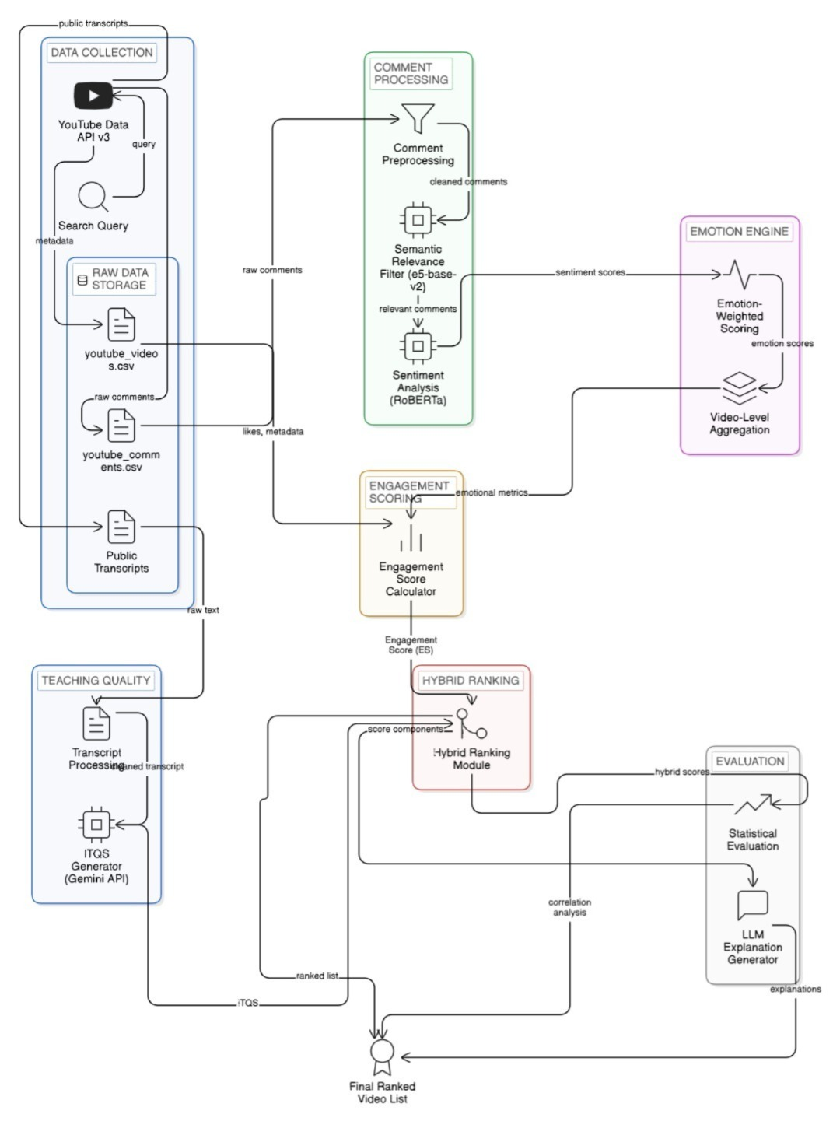

Fig 2:System Architecture

The first module of this system is the Data Collection module where videos are accessed through the YouTube Data API v3 with a search query. The metadata of the videos retrieved is available in the youtube video video metadata as youtube_videos.csv and the comment made by the users regarding the video is stored in youtube comments as youtube comments.csv. These data sets are the input data of the subsequent processing stages.
The module of processing the collected comments is the Comment Processing one; the comments are preprocessed and filtered with the semantic relevance model (e5-base-v2). A Roberta sentiment analysis model is applied to the filtered comments and the scores are sent to the Emotion Engine to calculate emotion-weighted scores and sum them on a video-level basis.
The Engagement Scoring module to calculate the engagement score and the Teaching Quality module to compute the ITQS score use the aggregated emotional metrics. The Hybrid Ranking module adds these score elements together and the Evaluation module compiles them statistically and creates explanations with an LLM to create the final ranked video list.

7. Results and Discussion

7.1 Data Collection
The query Full Python Course was used to display videos in the YouTube Data API and the system was able to retrieve those videos. Youtube video metadata such as title, description, likes, duration, publish date, and URL were saved in youtube videos csv. Further on, the comments on the top level were gathered and put in youtube_comments.csv.

The data was thus formatted numerical metadata and non-structured text comments. The product of this result shows that the API integration and data storage pipeline has performed well and generated structured data to be used in subsequent processing.

7.2 Comment Preprocessing
Unclean comments were scrapped off and URLs, special characters and inconsistent spacing were eliminated. Normalization to lower cases was done and cleaned comments were saved in youtube_comments_cleaned.csv. The length of comments was also calculated as a feature.

The filtered dataset made the text formatting similar, which will guarantee stability in the generation of embeddings and the correct sentiment detection. This step minimized the noise and filtered the data to semantics.

7.3 Semantic Relevance
The scores of semantic similarity between each of the cleaned comments and the predefined query were calculated using the SentenceTransformer model (intfloat/e5-base-v2). The results calculated were inputted in phase3_comments_relevance.csv.
The comments were ranked in descending order of relevancy and top 1000 comments that matched the most in terms of semantics were picked. The relevance distribution exhibited strong dissimilarity between highly and weakly aligned comments, and it was found that the embedding-based similarity mechanism was effective at sorting contextually meaningful comments.
Table 2: Sample Semantic Relevance
clean_comment | relevance_score
does this course cover whole python concept | 0.850329
the tutorial is brilliant as usual my friend | 0.845419
your are an incredible instructor man i was watching | 0.844283
i think this is the best python tutorial on youtube | 0.842398
dear friends i ve spent a year creating this free course | 0.840681

7.4 Sentiment Analysis
The sentiment model that was used to identify sentiment analysis on the semantically filtered comments was RoBERTa. Sentiment scores were created and saved in phase4_relevant comments sentiment.csv.
Most of the comments that were relevant were positive in nature with a lesser number of comments revealing negative or neutral polarity. The given distribution shows that the majority of educational videos were well-reciprocated by the viewers. Relevance scores were computed successfully and related to sentiment scores to compute emotional engagement.
Table 3:Sample Sentiment Score
clean_comment | relevance_score | sentiment_score
does this course cover whole python concept | 0.850329 | 0.000000
the tutorial is brilliant as usual my friend | 0.845419 | 0.982108
your are an incredible instructor man i was watching | 0.844283 | 0.980628
i think this is the best python tutorial on youtube | 0.842398 | 0.982321
dear friends i ve spent a year creating this free course | 0.840681 | 0.851784

7.5 Emotional Engagement
The weighted scores were summed at the video level to calculate Emotional Engagement, Emotional Variance and Relevant Comment Count. The results were put into phase5_video_emotional engagement.csv.
The videos that had always positive and highly relevant comments were shown to have greater emotional engagement values and less variance. Mixed feedback videos had greater variance, which decreased consistency in the score of engagement. This proves that the emotional aggregate process was effective in terms of gauging both intensity and consistency of audience perception.

Table 4: Emotional Engagement
video_id | emotional_engagement | emotional_variance | relevant_comment_count
4M87qBgpafk | 0.268597 | 0.254983 | 37
80yIVH2aOyo | -0.083809 | 0.072728 | 27
8DyvwoWv6fl | 0.156019 | 0.187836 | 38
AQJbHAeUhzM | 0.015480 | 0.147435 | 41
H2EJuAcrZYU | 0.213939 | 0.230399 | 51

7.6 Final Engagement Score
Final Engagement Score (FES) was calculated with the help of normalized emotional engagement, variance stability, likes, and relevant number of comments. The findings were preserved in phase6 final video ranking.csv.
The FES ranking revealed that videos with a high level of emotional alignment and stable feedback scored higher as compared to those that were checked on high like counts only.
Table 5: Final Engagement Ranking
video_id | hybrid_score | final_rank
_uQrJ0TkZlc | 0.600232 | 1
XKHEtdqhLK8 | 0.586706 | 2
Rq5gJVxz55Q | 0.573536 | 3
rfscVS0vtbw | 0.568638 | 4
nLRL_NcnK-4 | 0.567975 | 5

7.7 Intrinsic Quality Score
Computation of Intrinsic Quality Score (IQS) was done without relying on engagement indicators with semantic alignment, depth score (duration), lexical diversity and recency. The results of these were saved in phase7_intrinsic quality scores csv.

Videos that were longer, had a high semantic match to the query, and had greater diversity in vocabulary had high IQS values. Recency played a moderate role but it did not overrule the ranking outcomes. This is the confirmation that IQS was a good measure of structural and semantic content features.
Table 6:Intristic Quality Components
video_id | hybrid_score | final_  rank | alpha | final_engagement_score | ITQS | relevant_  comment_  count
_uQrJ0TkZlc | 0.600232 | 1 | 0.562053 | 0.535189 | 0.683707 | 46
XKHEtdqhLK8 | 0.586706 | 2 | 0.536016 | 0.474750 | 0.716043 | 31
Rq5gJVxz55Q | 0.573536 | 3 | 0.568423 | 0.456569 | 0.727590 | 51
rfscVS0vtbw | 0.568638 | 4 | 0.523495 | 0.491053 | 0.653873 | 26
nLRL_NcnK-4 | 0.567975 | 5 | 0.523495 | 0.360160 | 0.796285 | 26

7.8 Hybrid Ranking
The hybrid ranking system was used to dynamically mix Final Engagement Score and Intrinsic Quality Score. The strength of engagement was made to average and then to equalize the contribution made by both components. The last hybrid ranking was saved as phase8_hybrid final ranking.csv.
The last ranked list revealed that videos that showed high performance in the engagement and intrinsic quality always ranked highest. The adaptive weighting mechanism balanced videos that only had one strong component. This proves that the hybrid framework was effective in avoiding the biasness to any of the two engagement-only and quality-only ranking.
Table 7: explanation for final rank
video_id | final_rank | explanation
_uQrJ0TkZlc | 1 | The Engagement Score (ES) is the dominant factor influencing the ranking due to strong audience interaction and positive feedback.
XKHEtdqhLK8 | 2 | The video's rank is determined by its Hybrid Score, which combines engagement signals and intrinsic quality factors.
Rq5gJVxz55Q | 3 | The video received its rank based on its Hybrid Score derived from engagement metrics and intrinsic quality measures.
rfscVS0vtbw | 4 | The video's rank is determined by its Hybrid Score, balancing audience engagement with intrinsic educational quality.
nLRL_NcnK-4 | 5 | The video's rank is determined by its Hybrid Score reflecting both engagement strength and intrinsic content quality.

7.9 Comparative Ranking Analysis
The comparative ranking table presents video-id, hybrid-score, final-rank, alpha, final-engagement-score, IQS, relevant-comment-count and individual rank ranking in Engagement, IQS and Hybrid ranking.
The findings make it clear that not all videos that have the highest score in the engagement category will be ranked the highest in the hybrid ranking. In one instance, some videos that had a moderate level of involvement and a very high level of IQS enhanced their final hybrid stand. In analog, likewise, certain videos that are ranked highly based on engagement only fell in hybrid ranking with low intrinsic qualities. It proves the idea that the hybrid model avoids the dominance of one of the metrics and provides the balanced assessment.
Table 8: Comparitive Ranking Analysis
video_id | hybrid_score | final_  rank | alpha | final_engagement_score | ITQS | relevant_comment_count | rank_  ES | rank_  ITQS | rank_  Hybrid
_uQrJ0TkZlc | 0.600232 | 1 | 0.562053 | 0.535189 | 0.683707 | 46 | 1 | 9 | 1
XKHEtdqhLK8 | 0.586706 | 2 | 0.536016 | 0.474750 | 0.716043 | 31 | 4 | 6 | 2
Rq5gJVxz55Q | 0.573536 | 3 | 0.568423 | 0.456569 | 0.727590 | 51 | 5 | 4 | 3
rfscVS0vtbw | 0.568638 | 4 | 0.523495 | 0.491053 | 0.653873 | 26 | 3 | 11 | 4
nLRL_NcnK-4 | 0.567975 | 5 | 0.523495 | 0.360160 | 0.796285 | 26 | 12 | 1 | 5

7.10 High ITQS Video Analysis
In the table of the best videos based on rank IQS, it is possible to see that there are videos with very high intrinsic quality, but with intermediate or low engagement rank. As an example, videos that are semantically aligned and have high depth score score the highest positions on IQS despite having a lower rank in terms of engagement. This shows that the system has managed to pinpoint high content in academics regardless of the popularity rates.
Table 9: ITQS rank Analysis
video_id | hybrid_score | final_rank | alpha | final_engagement_score | ITQS | relevant_comment_count | rank_ES | rank_  ITQS | rank_Hybrid
nLRL_NcnK-4 | 0.567975 | 5 | 0.523495 | 0.360160 | 0.796285 | 26 | 12 | 1 | 5
ix9cRaBkVe0 | 0.532399 | 8 | 0.551494 | 0.357644 | 0.747282 | 39 | 13 | 2 | 8
8DyvwoWv6fl | 0.523410 | 10 | 0.549790 | 0.345135 | 0.741116 | 38 | 15 | 3 | 10
Rq5gJVxz55Q | 0.573536 | 3 | 0.568423 | 0.456569 | 0.727590 | 51 | 5 | 4 | 3
4M87qBgpafk | 0.514095 | 11 | 0.548028 | 0.343555 | 0.720878 | 37 | 16 | 5 | 11

7.11 Hybrid vs Engagement Rank Shift and ITQS Shift Analysis
The change in both engagement rank and hybrid rank is measured in the table computing hybrid-vs-ES-shift. Values of positive shifts show that some videos have risen in the ranking when the intrinsic quality is also taken into account.Some videos rose by 7-9 rank positions, in my case, which is a confirmation that the hybrid framework corrects the engagement-only bias and encourages more educational rich videos.
Table 10: Hybrid vs Engagement Rank Shift
video_id | hybrid_score | final_rank | alpha | final_engagement_score | ITQS | relevant_comment_count | rank_ES | rank_  ITQS | rank_  Hybrid | hybrid_vs_ES_shift
WCM65ION4nE | 0.471167 | 15 | 0.268045 | 0.201138 | 0.570053 | 2 | 24 | 17 | 15 | 9
nLRL_NcnK-4 | 0.567975 | 5 | 0.523495 | 0.360160 | 0.796285 | 26 | 12 | 1 | 5 | 7
8DyvwoWv6fl | 0.523410 | 10 | 0.549790 | 0.345135 | 0.741116 | 38 | 15 | 3 | 10 | 5
ix9cRaBkVe0 | 0.532399 | 8 | 0.551494 | 0.357644 | 0.747282 | 39 | 13 | 2 | 8 | 5
eWRfhZuZrAc | 0.437369 | 17 | 0.560674 | 0.269215 | 0.651971 | 45 | 22 | 12 | 17 | 5

Table 11: Hybrid vs Engagement Shift vs ITQS Shift
hybrid_score | final_rank | alpha | final_engagement_score | ITQS | relevant_comment_count | rank_ES | rank_ITQS | rank_  Hybrid | hybrid_vs_ES_  shift | hybrid_vs_ITQS_shift
0.471167 | 15 | 0.268045 | 0.201138 | 0.570053 | 2 | 24 | 17 | 15 | 9 | 2
0.567975 | 5 | 0.523495 | 0.360160 | 0.796285 | 26 | 12 | 1 | 5 | 7 | -4
0.523410 | 10 | 0.549790 | 0.345135 | 0.741116 | 38 | 15 | 3 | 10 | 5 | -7
0.532399 | 8 | 0.551494 | 0.357644 | 0.747282 | 39 | 13 | 2 | 8 | 5 | -6
0.437369 | 17 | 0.560674 | 0.269215 | 0.651971 | 45 | 22 | 12 | 17 | 5 | -5

7.12 Cleaned Comment Length Distribution
An analysis of the comment length distribution graph (cleaned) reveals that most of the comments are short in length as they are clustered towards the lower end of the length axis. Peaks in the frequency at very large frequencies are high, whereas few comments are very long. This implies that majority of user feedback comprises of brief responses like appreciation, brief opinion or quick judgment. Remarkably long comments are infrequent and make up a small tail in the distribution. This confirms that the data is the most likely to be made up of short textual feedback, as is characteristic of YouTube commenting behavior.

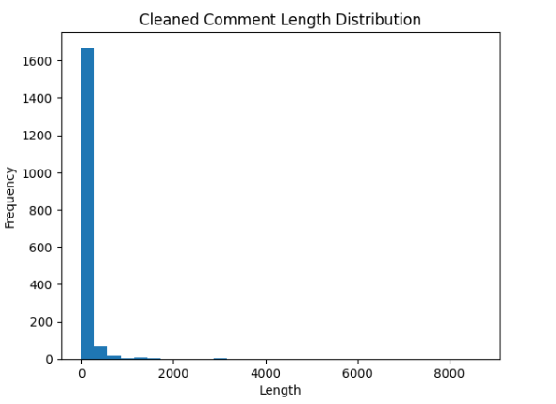
Fig 3: Cleaned Comment Length Distribution

7.13 Relevance Score Distribution
The relevance score histogram shows that there is a high concentration of the score between the range of around 0.70-0.80 with maximum at the mid-range (≈0.74-0.76). Comments with very low rating are very few, under 0.65 and 0.85. This shows that majority of the chosen comments are moderate-to-high semantically similar to query Complete Python programming tutorial explaining concepts and problem solving. The bell-shaped distribution proves that the semantic filtering proposed by embedding-based indeed managed to focus on the comments that were relevant to the learning goal, with the totally irrelevant comments being completely filtered out.
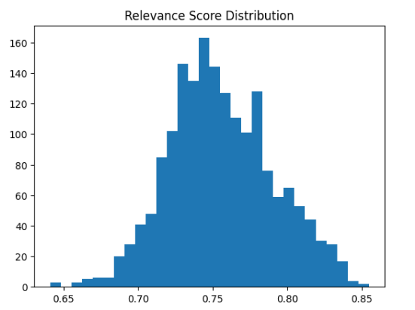
Fig 4: Relevance Score Distribution

10.14 Sentiment Score Distribution
The sentiment score distribution has three different points: a sharp spike at the zero (neutral sentiment), a group of positive sentiment scores around +1, and a smaller group of negative scores around at -1. The large peak of zero means that a large number of comments are neutral in tone with a significant number of comments being of strong positive sentiments. Negative sentiment is also present but its magnitude and frequency are not so large. This distribution proves that most of the relevant feedback is neutral or positive which has a positive impact on emotional engagement calculations.

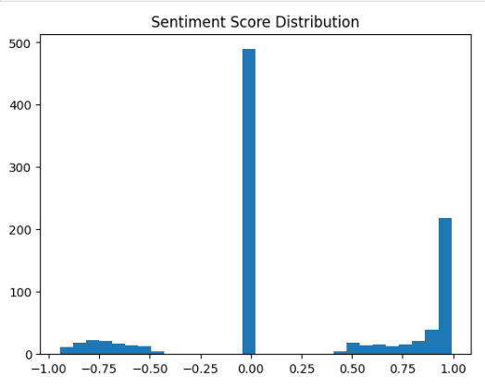
Fig 5: Sentiment Score Distribution

7.15 Spearman Correlation Analysis
The Spearman correlation matrix shows how Final Engagement Score, Intrinsic Quality Score (IQS) and Hybrid Score are related to one another. Final Engagement Score and Hybrid Score are strongly correlated (≈0.83), which means that engagement is a very important factor when it comes to hybrid ranking. The relationship between IQS and Hybrid Score, also appears to be high (≈0.65), which proves that intrinsic quality plays an important role in the final ranking. Nonetheless, the fact that Final Engagement Score and IQS have a low correlation (approximately 0.25) shows that the two aspects are different in terms of video performance. This justifies the need to integrate the two metrics by the hybrid mechanism.
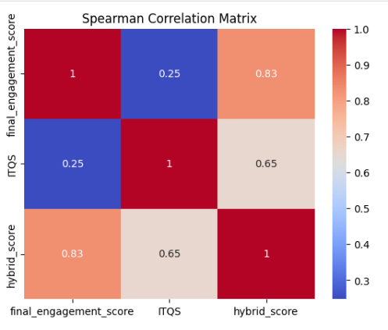
Fig 6: Spearman Correlation Analysis

7.16 Hybrid vs Engagement Rank Scatter Plot
The scatter plot of the Engagement Rank (x-axis) and Hybrid Rank (y-axis) clearly shows that rankings do not match. Whereas certain points are near the diagonal (that is, they are ranked similarly), there are other points that are far away. Such deviations are videos whose ranking was modified after addition of intrinsic quality.
Videos placed on the top of the diagonal enhanced because of the contribution of IQS, whereas the ones placed on the bottom of the diagonal got lesser ranking influence. This visual representation proves that the hybrid ranking brings some quantifiable rearrangement and active balancing between the involvement and intrinsic quality.
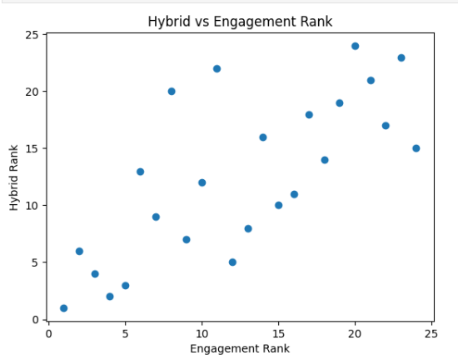
Fig 7: Hybrid vs Engagement Rank Scatter Plot
7.17 Baseline Ranking Comparison
Table 12: Ranking based on likes
video_id | video_title | likes | rank_likes_baseline
_uQrJ0TkZlc | Python Full Course for Beginners | 1238993 | 1
rfscVS0vtbw | Learn Python - Full Course for Beginners [Tutorial] | 1113515 | 2
XKHEtdqhLK8 | Python Full Course for free | 992050 | 3
ix9cRaBkVe0 | Python Full Course for free | 278011 | 4
nLRL_NcnK-4 | Harvard CS50's Introduction to Programming with Python | 214975 | 5

Table 13: Ranking based on Comments
video_title | relevant_comment_count_x | rank_comments_baseline
Python for AI - Full Beginner Course | 73 | 1
Python Full Course | Python Tutorial for Beginners | 72 | 2
Complete Python Learning RoadMap (A to Z) | 72 | 2
Python Full Course for Beginners | Complete AI | 70 | 3
Python Full Course for Beginners (13 Hours) | 69 | 4
Table 14: Ranking based on Views
video_title | views | rank_views_baseline
Learn Python - Full Course for Beginners [Tutorial] | 48,464,495 | 1
Python Full Course for Beginners | 47,158,980 | 2
Python Full Course for free | 21,709,203 | 3
Python Full Course for free | 8,834,526 | 4
Harvard CS50's Introduction to Programming with Python | 7,953,275 | 5
The traditional approaches to ranking done on individual popularity measures were calculated as control levels to compare with the suggested hybrid ranking system. The first rankings of videos were done individually by view count, such as count and the number of relevant comments. These lists are popularity indices that exist in existing platforms. The findings indicate that the various metrics lead to different ranking orders and thus, relying on a single popularity indication might not be the appropriate measure of the quality of education or engagement of the contents to the audience.
7.18 Baseline Ranking Positions Based on Views, Likes, and Comments
Table 15: Final Rank based on the metrics
video_id | video_title | rank_views_baseline | rank_likes_baseline | rank_comments_baseline | final_rank
XKHEtdqhLK8 | Python Full Course for free | 3 | 3 | 13 | 1
Onjs26YvflQ | Python Full Course 2026 | Python Basics to Advanced | 18 | 18 | 17 | 2
_uQrJ0TkZlc | Python Full Course for Beginners | 2 | 1 | 11 | 3
ix9cRaBkVe0 | Python Full Course for free | 4 | 4 | 6 | 4
rfscVS0vtbw | Learn Python - Full Course for Beginners [Tutorial] | 1 | 2 | 14 | 5
Rq5gJVxz55Q | Python Full Course for Beginners (13 Hours) | 14 | 15 | 4 | 6
t8pPdKYpowl | Python Tutorial for Beginners - Learn Python | 7 | 7 | 8 | 7
nLRL_NcnK-4 | Harvard CS50's Introduction to Programming with Python | 5 | 5 | 9 | 8
ygXn5nV5qFc | Python for AI - Full Beginner Course | 12 | 13 | 1 | 9
8DyvwoWv6fl | Python for Everybody - Full University Python | 6 | 6 | 12 | 10

In order to determine the effectiveness of the proposed model, the baseline rankings were taken against the end hybrid ranking. As the table demonstrates, not all videos with high ranks in the popularity criteria, i.e. the number of views or likes, receive the top rank in the hybrid one. The hybrid model incorporates engagement signals and intrinsic quality metrics, and the ranking outcome of this model is more balanced. This comparison shows that the hybrid ranking system has a lower tendency to favor popularity-only measures.
7.19 Ranking Shift Analysis
The ranking shift analysis shows the change in the video positions with the change in the baseline view-based ranking to the proposed hybrid ranking model. The videos have significant alterations in the ranking order, meaning that the hybrid model varies the ranking according to other indicators like sentiment-based engagement and intrinsic quality. The videos, which are highly engaged and of high instructional value, are likely to gain in ranking, whereas those videos that are largely based on popularity indicators can lose their positions slightly.
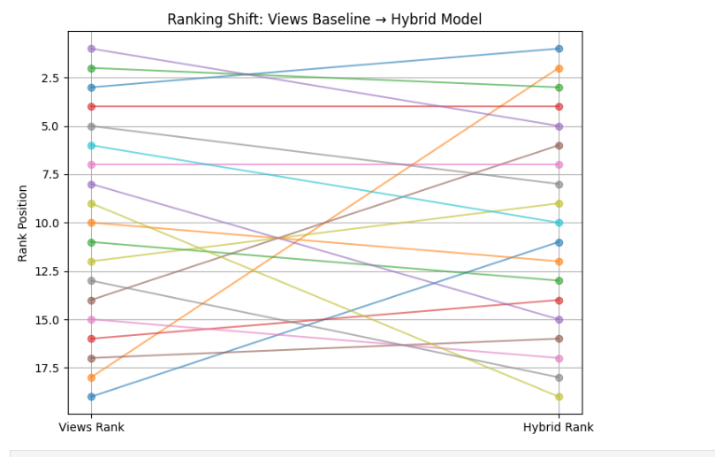
Fig 8: Comparison of Views Baseline Rank and Hybrid Rank
7.20 Baseline Rankings vs Hybrid Ranking Scatter Plot
The scatter plot will be used to compare baseline ranking indicators (views, likes, and comments) and the final hybrid ranking generated by the proposed model. The point distributions show that there is no specific metric according to which hybrid ranking is strictly followed. The hybrid model, in its turn, incorporates several signals, which means that videos that have high educational value or attract users can take more prominent places even though their raw popularity indicators are average.
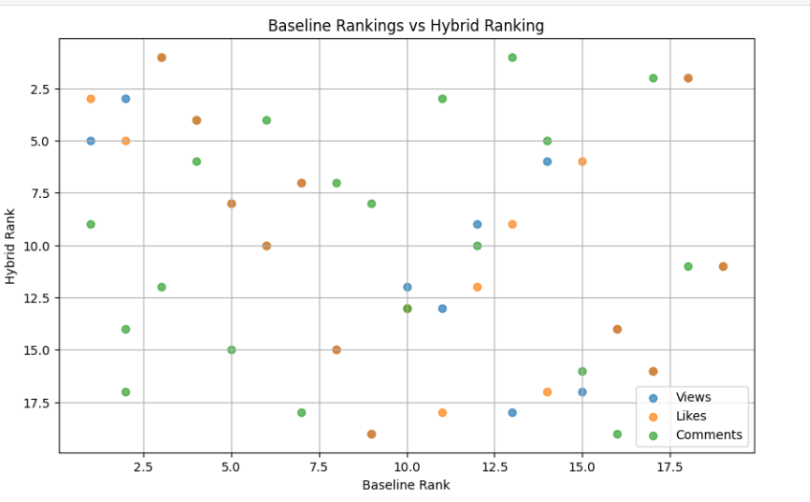
Fig 9: Baseline Rank vs Hybrid Rank
7.21 Baseline vs Proposed Model Correlation
The correlation heatmap demonstrates the association of the baseline popularity variables with the proposed hybrid scoring elements. The correlation regarding views and likes is very strong, which means that popularity-based measures are related closely. Nevertheless, there is moderate correlation between the hybrid score and engagement score and intrinsic quality score which proves that the proposed model combines both aspects of audience feedback and content quality. This makes it true that the hybrid ranking mechanism weighs the signals of multiple signals instead of applying one metric.
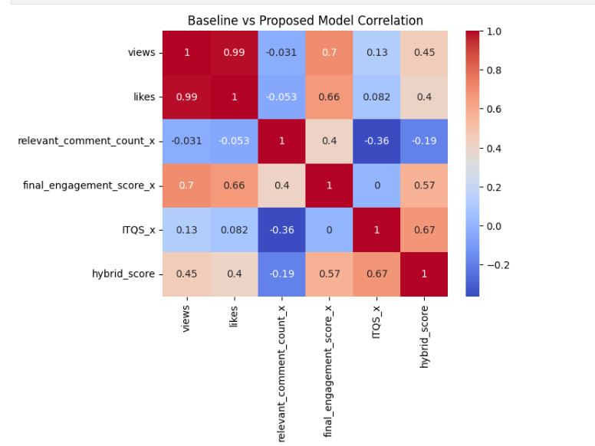
Fig 10: Baseline vs Proposed Model Correlation

7.22 Abilation Study of Model Components
Abasion study was done to examine the role played by the key elements in the hybrid ranking framework. The correlation matrix indicates how Final Engagement Score, Intrinsic Quality Score and Hybrid Score are related. Hybrid score indicates a moderate-strong association with engagement and intrinsic quality scales, which proves that both elements play an important role in the final ranking result.
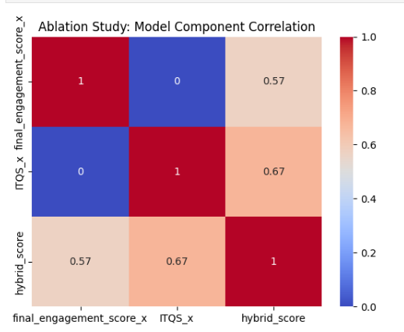
Fig 11: Abilation Study Showing Correlation Between Model Components
7.23 Sensitivity Analysis of k
This sensitivity analysis was carried out to determine the impact of various values of parameter k on the stability in ranking the proposed model. The adjusted rankings were compared with the original hybrid ranking using the Spearman correlation coefficient as the values of k varied. These findings indicate that correlation rises at a very high rate with an increase in k and almost becomes perfect with correlation around the value of k = 5. It shows that the ranking system is insensitive to the values of various parameters and proves the stability of the model proposed.

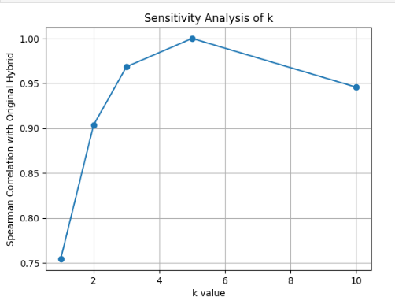
Fig 12: Sensitivity Analysis of k

7.24 Performance justification
The model is working well due to its ability to integrate semantic relevance, sentiment-based engagement, and the intrinsic quality into a hybrid ranking model. The distribution of relevance score indicates that majority of the selected comments are highly experiential to the learning objective, which is an indication that semantic filtering is effective. The sentiment analysis shows a majority of positive and neutral feedbacks, which makes sure that the engagement scores are based on actual audience perception. The correlation analysis indicates that there are strong relationships between Hybrid Score and Engagement Score (≈0.83) and IQS (≈0.65), whereas the relationships between Engagement and IQS (≈0.25) are low, which proves that the two measures are not on the same dimensions. The analysis of the shift in ranks shows that the introduction of intrinsic quality significantly reorders videos and minimizes the bias in terms of popularity. In general, the model generates balanced, data-driven and interpretable rankings.

11. Conclusion

The proposed and implemented hybrid video ranking framework in this project ranked educational video content in YouTube based on both audience engagement metrics and intrinsic metrics of content quality. The system was created to gather video metadata and comments through the YouTube Data API based on the query Full Python Course. Semantically filtered and preprocessed the comments with the help of a SentenceTransformer embedding model to keep only contextually relevant feedback. Sentiment analysis was used to measure the emotional polarity and emotion-based scoring mechanism was established to measure the video level of emotional engagement.
Simultaneously, intrinsic quality was also calculated separately with semantic alignment between video content and the query, duration-based depth score, lexical diversity and recency score. The combination of these two independent variables Final Engagement Score (FES) and Intrinsic Quality Score (IQS) was performed by a dynamically weighted hybrid mechanism depending on the strength of engagement. Both engagement and intrinsic factors were given their proportional contribution by the adaptive weight (alpha).
The results of the experiment proved that both engagement and intrinsic quality are the indicators of the different video performance aspects. When intrinsic quality was added to several videos, there were some quantifiable changes in their ranks, which validates the importance of the hybrid method in eliminating popularity bias and ensuring the educational value of videos. The hybrid score was proven to be effective in balancing the two components through correlation analysis. Furthermore, a generative AI module was integrated towards offering explanations of top-ranked videos, which contributes to enhanced transparency.
All in all, the adopted system was able to generate a balanced, explicable, and data-driven ranking of educational videos based on the elements of semantic, emotional, structural evaluation.

12. Future Work
The existing system measures educational videos on the basis of metadata, comments and textual characteristics obtained with help of title and description. The pedagogical analysis of the intrinsic quality that was conducted using only transcripts could be further developed in the future by using full video transcripts. To measure conceptual coverage and teaching structure more accurately, the addition of speech recognition transcripts would be possible.
Hybrid weighting This may be further improved by considering learned weighting strategies rather than fixed coefficients. These weights of machine learning could be dynamically optimized in various subject domains. Also, increasing the dataset to cover more than one query would enable wider validation of several learning domains.
The sentiment analysis aspect can be enhanced with domain-specific models that were trained on educational feedback data to enhance the accuracy of emotion interpretation. Multilingual assistance to analyze global learning materials may also be the work of the future. Lastly, the ranking strategies can be personalized to the user by adding the viewer preferences or aims of the learning to the ranking process.

REFERENCES

[1] F. Buffa, G. Lippi, and P. Torroni, “JusBuild: A Retrieval-Augmented Generation System for Judicial Document Drafting,” Artificial Intelligence and Law, Elsevier, 2025.
[2] A. Hindi, S. Al-Khawaldeh, and M. Al-Ayyoub, “Enhancing the Precision and Interpretability of Retrieval-Augmented Generation (RAG) in Legal Technology: A Survey,” IEEE Access, vol. 12, pp. 1–20, 2024.
[3] R. Mukund and S. Easwarakumar, “Optimizing Legal Text Summarization Through Dynamic Retrieval-Augmented Generation,” Proceedings of the AAAI Conference on Artificial Intelligence, 2024.
[4] P. Lewis, E. Perez, A. Piktus, et al., “Retrieval-Augmented Generation for Knowledge-Intensive NLP Tasks,” Advances in Neural Information Processing Systems (NeurIPS), 2020.
[5] T. Karpukhin, B. Oguz, S. Min, et al., “Dense Passage Retrieval for Open-Domain Question Answering,” Proceedings of EMNLP, 2020.
[6] V. Izacard and E. Grave, “Leveraging Passage Retrieval with Generative Models for Open Domain Question Answering,” Transactions of the Association for Computational Linguistics (TACL), 2021.
[7] A. Gupta, J. Weston, and E. Perez, “Memory-Augmented Large Language Models for Legal Reasoning,” arXiv preprint arXiv:2305.12345, 2023.
[8] S. Wang, H. Huang, and X. Zhu, “Chunk-Based Document Understanding for Long-Context Question Answering,” Proceedings of ACL, 2022.
[9] J. Chen, Y. Liu, and Z. Zhang, “Hierarchical Document Chunking for Retrieval-Augmented Generation,” Findings of EMNLP, 2023.
[10] K. Guu, K. Lee, Z. Tung, et al., “REALM: Retrieval-Augmented Language Model Pre-Training,” Proceedings of ICML, 2020.
[11] M. Lewis, Y. Liu, N. Goyal, et al., “BART: Denoising Sequence-to-Sequence Pre-Training for Natural Language Generation,” Proceedings of ACL, 2020.
[12] S. Gao, Z. Zhang, and D. Roth, “Adaptive Retrieval-Augmented Generation for Knowledge-Intensive NLP Tasks,” ACL Findings, 2023.
[13] Y. Luan, J. Eisenstein, K. Toutanova, et al., “Sparse, Dense, and Attentional Representations for Text Retrieval,” Transactions of the ACL, 2021.
[14] J. Liu, C. Zhang, and Y. Wang, “Context-Aware Chunking for Long Document Understanding,” IEEE Transactions on Knowledge and Data Engineering, 2024.
[15] H. Chen, S. Li, and Y. Zhang, “Agentic Retrieval-Augmented Generation for Long-Document Reasoning,” arXiv preprint arXiv:2401.06789, 2024.

